1,11,21....201

{'n_estimators': 201}----0.9817533330914605

param_grid = {

'n_estimators': np.arange(1,211,10),

}

regressor=LGBMRegressor(

learning_rate=0.1,

random_state=90)

GS=GridSearchCV(regressor,param_grid,cv=k)

GS.fit(x_train,y_train)

print(GS.best_params_)

print(GS.best_score_)

3...20

#{'max_depth': 18}----0.9818521630436967

param_grid={

'max_depth': np.arange(3,21,1),

}

regressor=LGBMRegressor(n_estimators=201,

learning_rate=0.1,

random_state=90)

GS=GridSearchCV(regressor,param_grid,cv=k)

GS.fit(x_train,y_train)

print(GS.best_params_)

print(GS.best_score_)

1,11,21...101

{'num_leaves': 91}-----0.9872405075721262

param_grid={

'num_leaves': np.arange(1,111,10),

}

regressor=LGBMRegressor(n_estimators=201,

learning_rate=0.1,

max_depth=18,

random_state=90)

GS=GridSearchCV(regressor,param_grid,cv=k)

GS.fit(x_train,y_train)

print(GS.best_params_)

print(GS.best_score_)

1,11,21...101

#{'min_data_in_leaf': 1}---0.988489817505646

param_grid={

'min_data_in_leaf': np.arange(1,111,10),

}

regressor=LGBMRegressor(n_estimators=201,

learning_rate=0.1,

max_depth=18,

num_leaves=91,

random_state=90)

GS=GridSearchCV(regressor,param_grid,cv=k)

GS.fit(x_train,y_train)

print(GS.best_params_)

print(GS.best_score_)

5,10,15...255

#{'max_bin': 90}---0.9889003050112304

param_grid={

'max_bin': np.arange(5,256,5),

}

regressor=LGBMRegressor(n_estimators=201,

learning_rate=0.1,

max_depth=18,

num_leaves=91,

min_data_in_leaf=1,

random_state=90)

GS=GridSearchCV(regressor,param_grid,cv=k)

GS.fit(x_train,y_train)

print(GS.best_params_)

print(GS.best_score_)

0,0.1...1

#{'feature_fraction': 0.5}---0.990569601079493

param_grid={

'feature_fraction': np.linspace(0,1,11),

}

regressor=LGBMRegressor(n_estimators=201,

learning_rate=0.1,

max_depth=18,

num_leaves=91,

min_data_in_leaf=1,

max_bin=90,

random_state=90)

GS=GridSearchCV(regressor,param_grid,cv=k)

GS.fit(x_train,y_train)

print(GS.best_params_)

print(GS.best_score_)

0,0.1...1

#{'bagging_fraction': 0.1}---0.990569601079493

param_grid={

'bagging_fraction': np.linspace(0,1,11),

}

regressor=LGBMRegressor(n_estimators=201,

learning_rate=0.1,

max_depth=18,

num_leaves=91,

min_data_in_leaf=1,

max_bin=90,

feature_fraction=0.5,

random_state=90)

GS=GridSearchCV(regressor,param_grid,cv=k)

GS.fit(x_train,y_train)

print(GS.best_params_)

print(GS.best_score_)

0,10,20,...100

{'bagging_freq': 0}----0.990569601079493

np.arange(0,101,10),

regressor=LGBMRegressor(n_estimators=201,

learning_rate=0.1,

max_depth=18,

num_leaves=91,

min_data_in_leaf=1,

max_bin=90,

feature_fraction=0.5,

bagging_fraction=0.1,

random_state=90)

GS=GridSearchCV(regressor,param_grid,cv=k)

GS.fit(x_train,y_train)

print(GS.best_params_)

print(GS.best_score_)

0,0.05,0.1...1

#{'reg_alpha': 0.25}----0.9908192355263905

np.linspace(0,1,21),

0,0.05,0.1...1

#{'reg_lambda': 0.0}---0.9908192355263905

np.linspace(0,1,21),

#{'min_split_gain': 0.0}---0.9908192355263905

np.linspace(0,1,21),

RF.。。。。----明天完整调参以下 看看最终情况

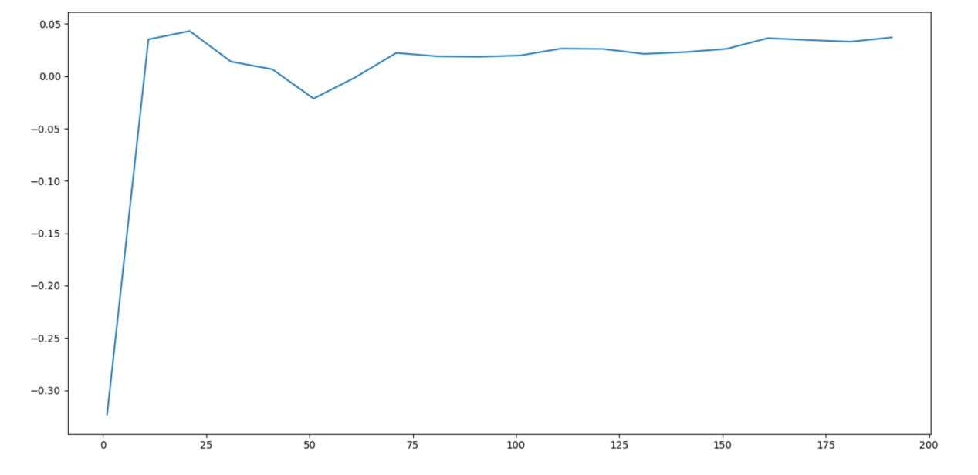

.....

这调个啥？---换个模型？-----也许深度学习bp?

LGBM。。。。

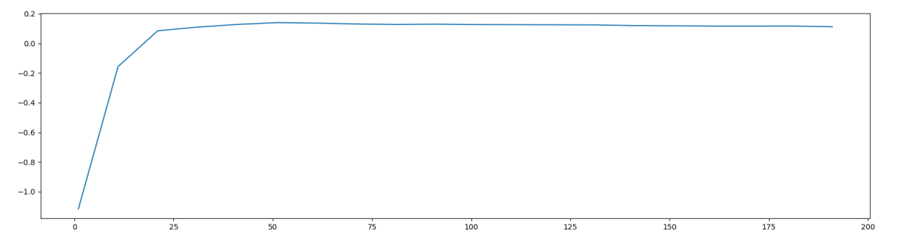

那我来个主成分分析？

#n_estimators

#0.04318035905162898 21............这。。。。

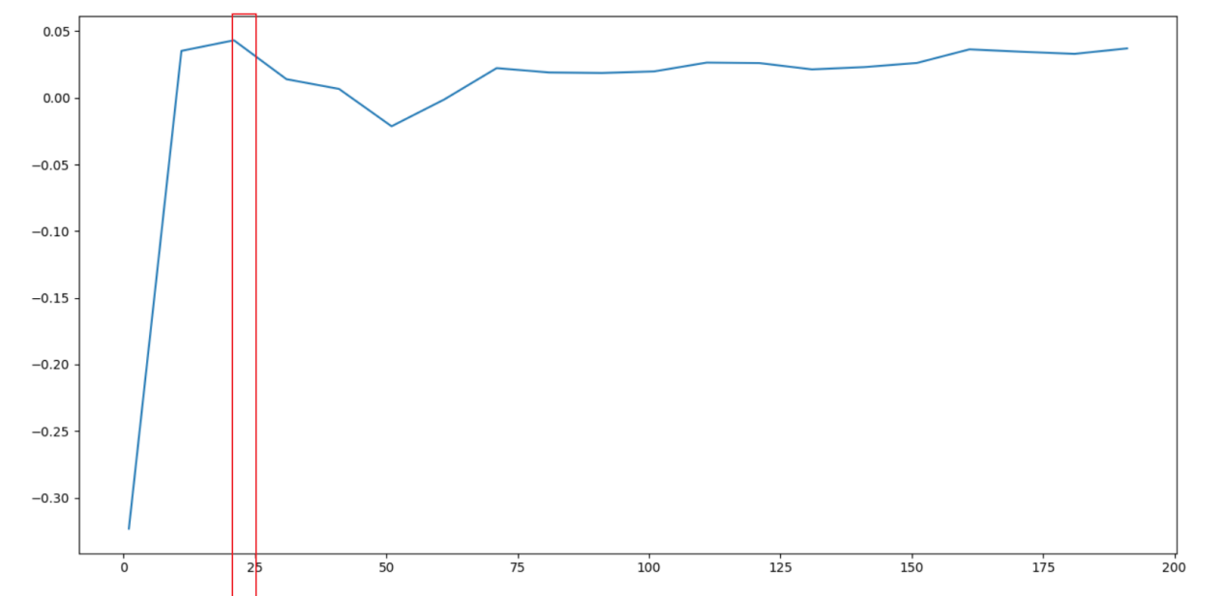

#0.05938686370704702 4----19

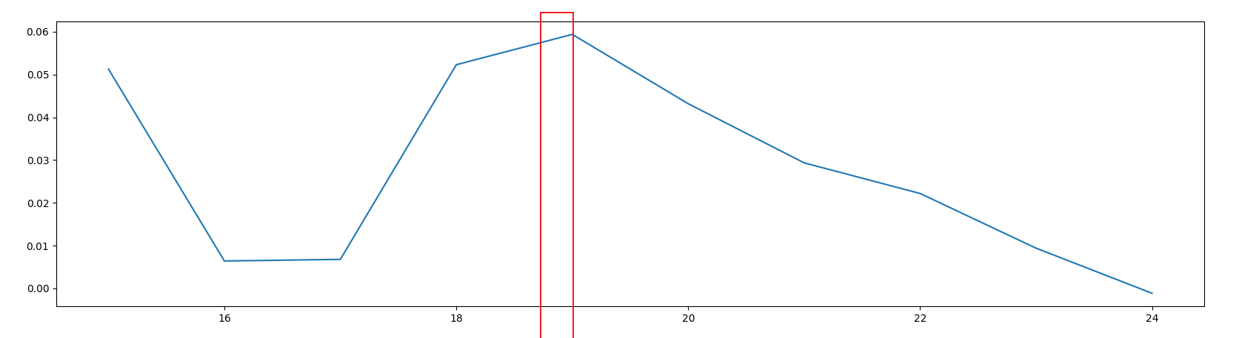

'max_depth': np.arange(1,20,1), # 调整树的深度

#{'max_depth': 19}----0.9841352601456231---没看错吧。。。

按这个表格来吧

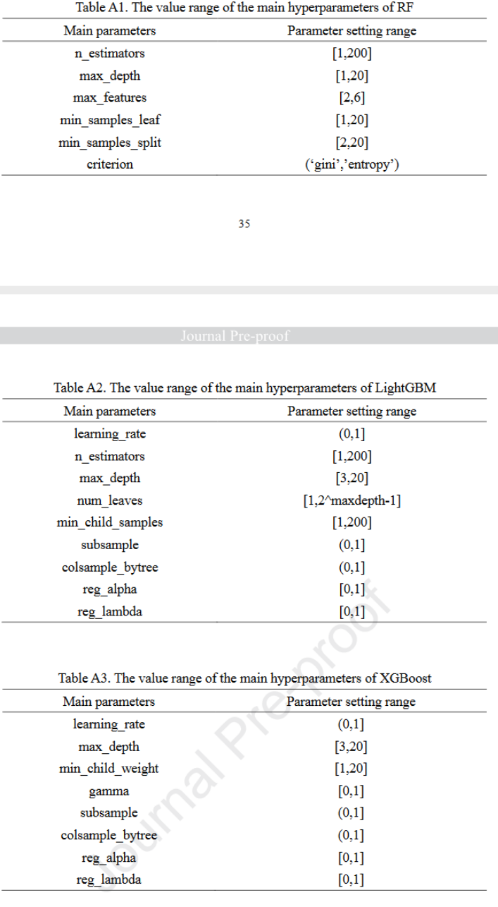

#n_estimators

1-200

#0.1406059435903892 51........这。。。。

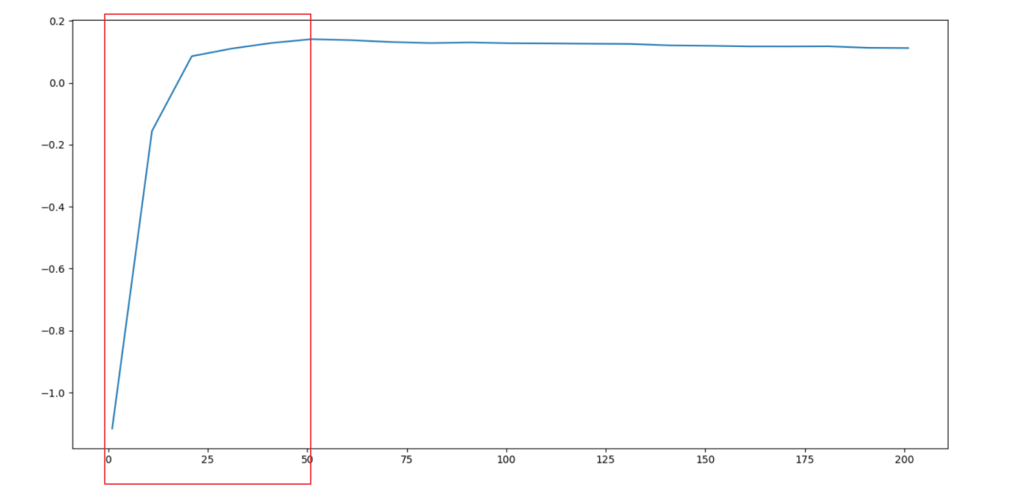#0.14365427927149074 5---50

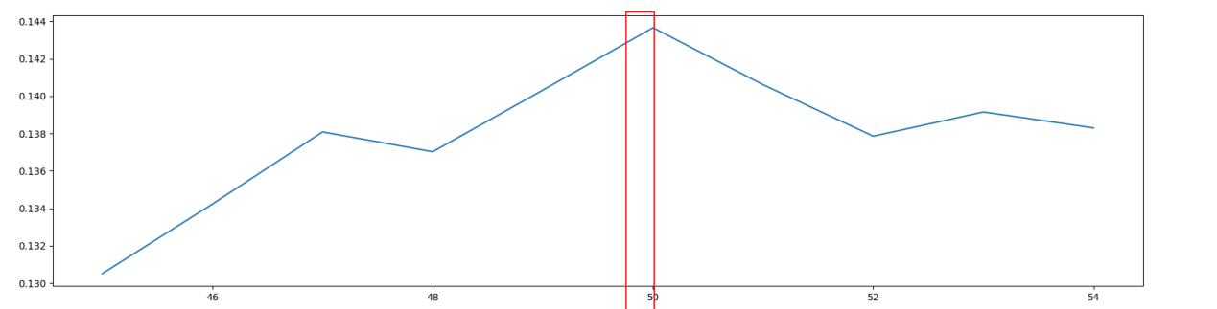

<https://www.bilibili.com/video/BV13h4y147GK?p=13&vd_source=a6f120aa01d7d9a8c8667419efef8181>

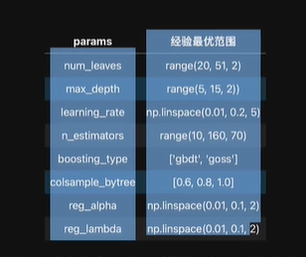

<https://blog.csdn.net/qq_35679701/article/details/107239487>

<https://blog.51cto.com/u_15274944/5042180>

<https://www.jianshu.com/p/3f114699c6ed>

[参考这个步骤，范围再说](https://www.jianshu.com/p/3f114699c6ed)

[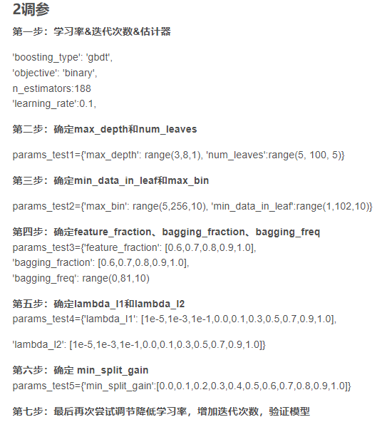](https://www.jianshu.com/p/3f114699c6ed)

[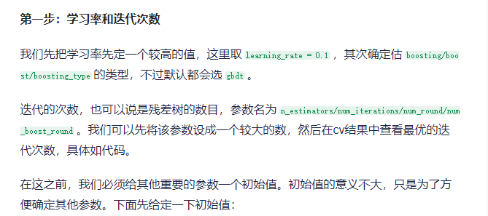](https://www.jianshu.com/p/3f114699c6ed)

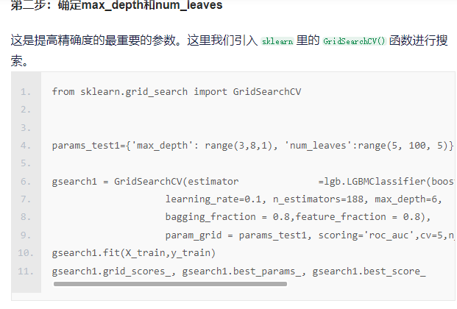

3-10

#{'max_depth': 10}---0.9559120010637996

param_grid={

'max_depth': np.arange(3,11,1),

}

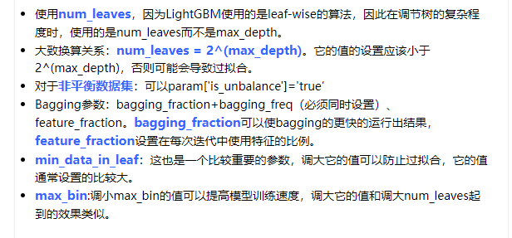

1-2^maxDepth-1

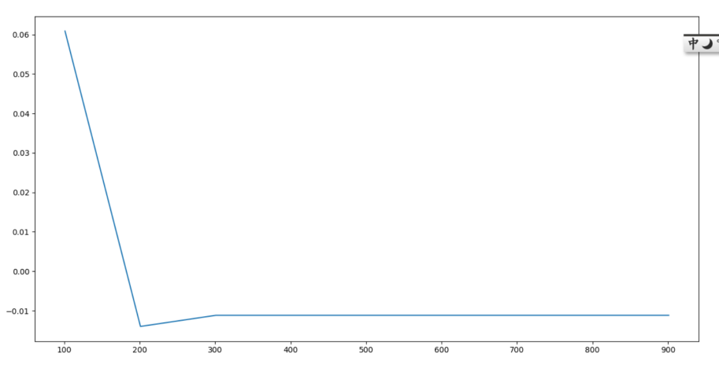

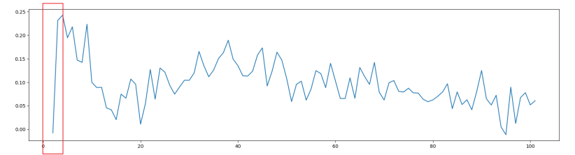

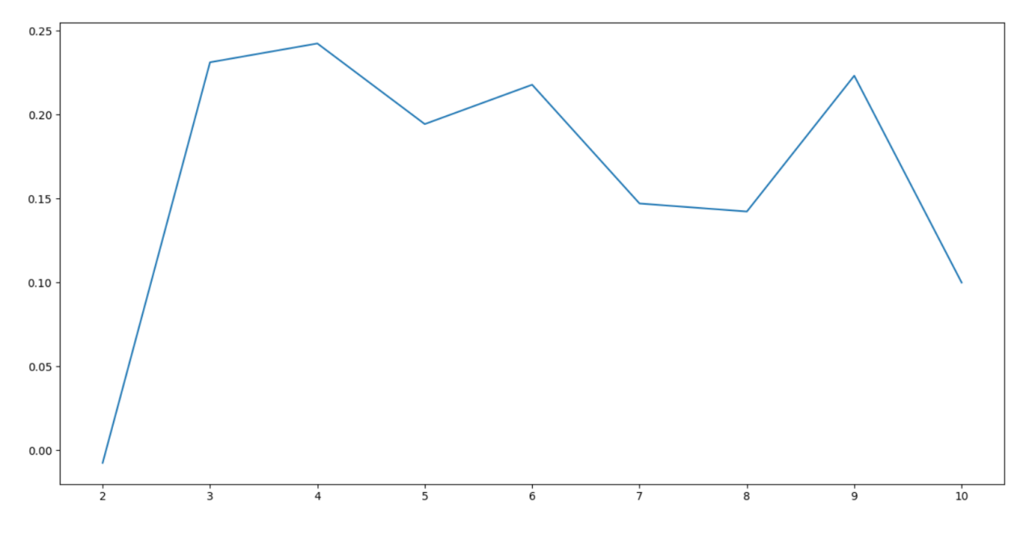

#num_leaves------4

1-100

#{'min_data_in_leaf': 5}------0.9586173274474092--num_leaves=31---

#{'min_data_in_leaf': 56}-----0.8295643474004241

param_grid={

'min_data_in_leaf': np.arange(1,101,1),

}

5-255

#{'max_bin': 255}---0.9586173274474092--默认

param_grid={

'max_bin': np.arange(5,256,5),

}

0-1

#{'feature_fraction': 0.6}----0.9595528477936286

param_grid={

'feature_fraction': np.linspace(0.1,1,10),

}

0-1

#{'bagging_fraction': 0.1}---0.9595528477936286

param_grid={

'bagging_fraction': np.linspace(0.1,1,10),

}

0-100

#{'bagging_freq': 0}---0.9595528477936286

param_grid={

'bagging_freq': np.arange(0,101,1),

}

0-1

#{'reg_alpha': 0.30000000000000004}----0.9598494540684666

param_grid={

'reg_alpha': np.linspace(0,1,10),

}

0-1

#{'reg_lambda': 0.0}---0.9598494540684666--默认

param_grid={

'reg_lambda': np.linspace(0,1,11),

}

是的，`lambda_l1` 和 `lambda_l2` 在 LightGBM 中分别对应于正则化的参数，而 `reg_alpha` 和 `reg_lambda` 是与之等效的参数。它们的作用相同，只是命名不同。

具体来说：

- `lambda_l1` 和 `reg_alpha`：都是 L1 正则化的强度参数。

- `lambda_l2` 和 `reg_lambda`：都是 L2 正则化的强度参数。

它们的取值范围是非负实数，通常在 [0, +∞) 之间。默认情况下，它们的取值都是 0，表示不应用正则化。你可以根据实际问题的需要调整这些参数，以控制模型的正则化强度。使用交叉验证等方法可以帮助你找到最佳的参数取值，以优化模型性能。

#{'min_split_gain': 0.0}---0.9598494540684666--默认

param_grid={

'min_split_gain': np.linspace(0,1,11),

}

#{'learning_rate': 0.45}----0.9800589612047853

param_grid={

'learning_rate': np.linspace(0,1,21),

}